<https://www.jenkins.io/doc/tutorials/build-a-node-js-and-react-app-with-npm/>

<https://qascript.com/create-a-jenkins-cd-pipeline-to-build-node-js-and-react-application-using-npm/>

<https://www.taniarascia.com/continuous-integration-pipeline-docker/>

**Install Jenkins on Docker**

参考

<https://qascript.com/install-jenkins-on-docker/>

这篇似乎也不错

<https://www.taniarascia.com/continuous-integration-pipeline-docker/>

查看版本

docker version

创建网络连接

docker network create Jenkins

查看网络连接

docker network ls

Create the following volumes to share the Docker client TLS certificates needed to connect to the Docker daemon and persist the Jenkins data using the following commands:

docker volume create jenkins-docker-certs

docker volume create jenkins-data

In order to execute Docker commands inside Jenkins nodes, download and run the docker:dind Docker image using the following command:

docker container run --name jenkins-docker --rm --detach ^

--privileged --network jenkins --network-alias docker ^

--env DOCKER_TLS_CERTDIR=/certs ^

--volume jenkins-docker-certs:/certs/client ^

--volume jenkins-data:/var/jenkins_home ^

docker:dind

Download the jenkinsci/blueocean image and run it as a container in Docker using the following command:

docker container run --name jenkins-blueocean --rm ^

--network jenkins --env DOCKER_HOST=tcp://docker:2376 ^

--env DOCKER_CERT_PATH=/certs/client --env DOCKER_TLS_VERIFY=1 ^

--volume jenkins-data:/var/jenkins_home ^

--volume jenkins-docker-certs:/certs/client:ro ^

--publish 8080:8080 --publish 50000:50000 jenkinsci/blueocean

记录下Jenkins的password

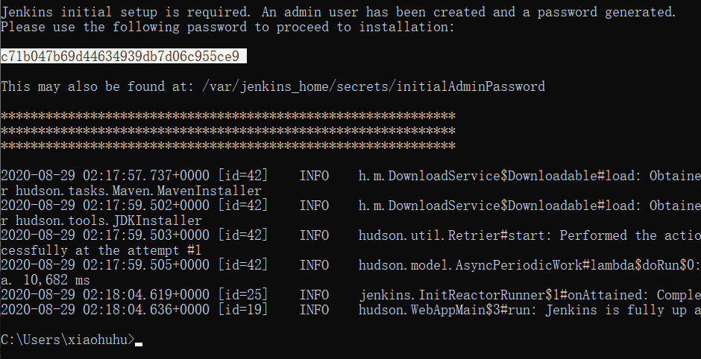

访问：<http://localhost:8080/>

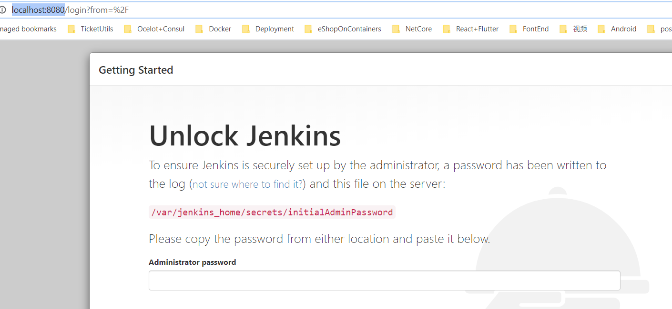

输入先前的密码

建立Admin用户

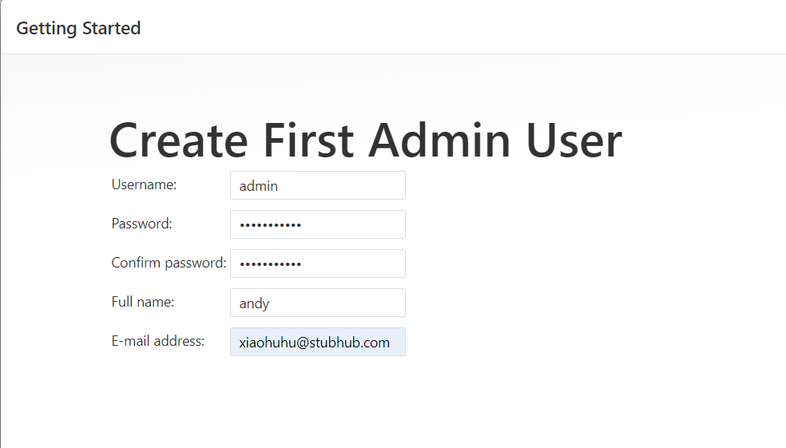

## 登录Jenkins，建立Pipeline

1. Login into Jenkins and click on **New Item**.

2. In the **Enter an item name** field, specify the name for your new Pipeline project “simple-node-js-react-npm-app”

3. Click to select **Pipeline**and click on **OK.**

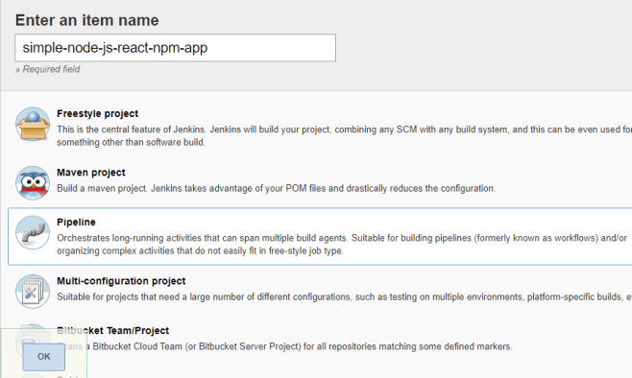

4. Provide a brief description for your Pipeline in the **Description** field “An entry-level Pipeline demonstrating how to use Jenkins to build a simple Node.js and React application with npm”.

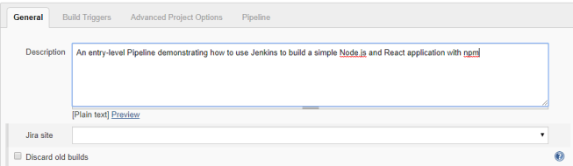

5. Click the **Pipeline** tab at the top of the page to scroll down to the **Pipeline** section.

6. From the **Definition** field, choose the **Pipeline script from SCM** option. This option instructs Jenkins to obtain your Pipeline from Source Control Management (SCM), which will be your locally cloned Git repository.

7. From the **SCM** field, choose **Git**.

8. In the **Repository URL** field, enter the Github repository Url “https://github.com/patebija/simple-node-js-react-npm-app.git”

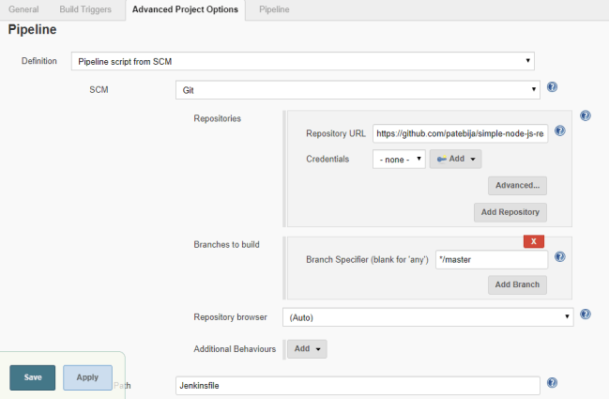

9. Click **Save** to save your new Pipeline project.

走到Jenkins Deliver这一步没走通， 换下面的方式：

# Docker + Nginx + Jenkins 部署 React

<https://blog.csdn.net/chengly0129/article/details/70292953>

<http://www.jianshu.com/p/052a2401595a>

参照这篇

<https://segmentfault.com/a/1190000014924494>